Micah Hoffmann

Assignment 02

July 2, 2019

The following document details a basic website that takes form data as input, and outputs it to a .txt file. The website consists of 3 primary elements or code types that combine to make it function: 1) ASP.NET C# 2) HTML5 3) CSS.

## C# Code

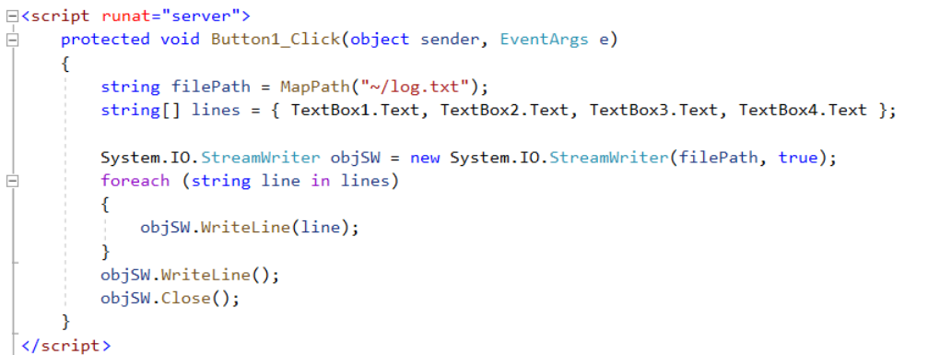

## HTML Code

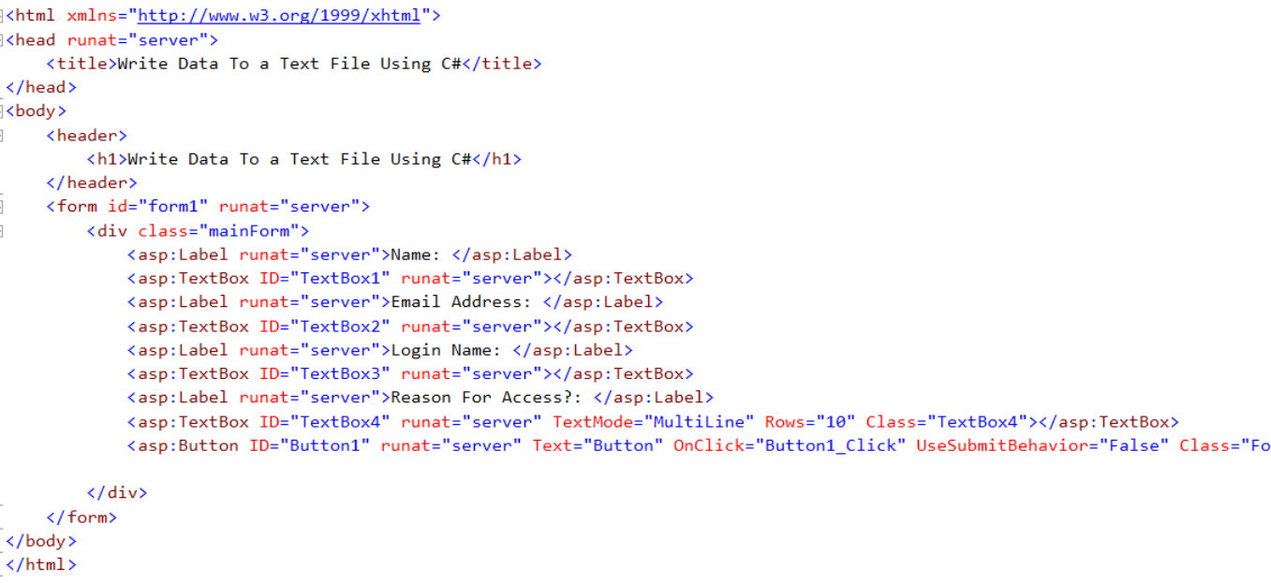

## CSS Code

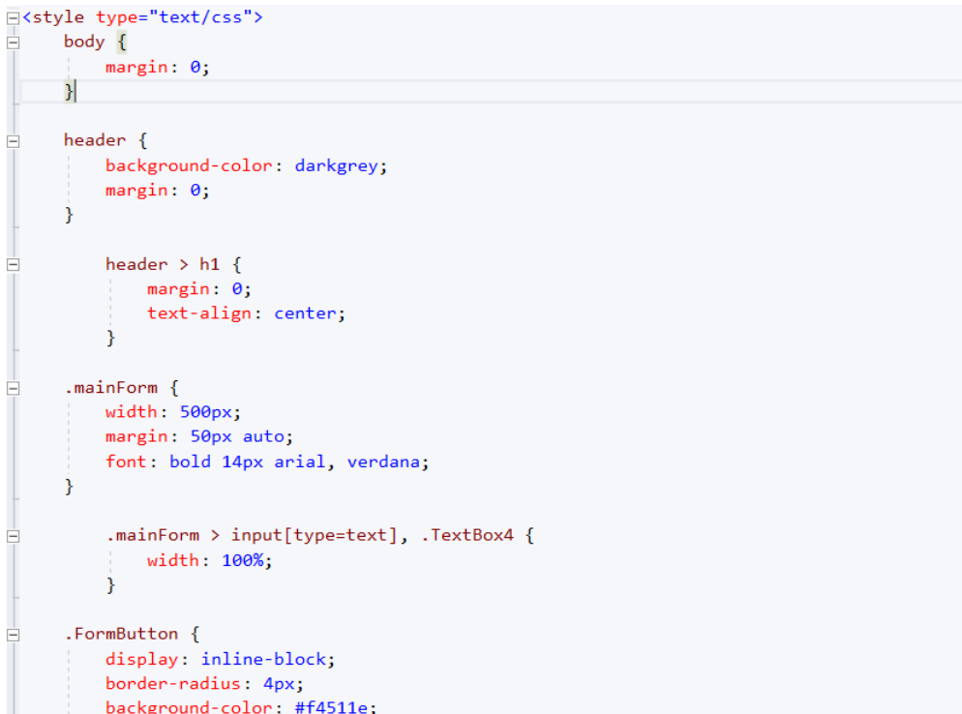

The application is a very basic example of the client vs server interaction. When the website is launched the HTML is render, and styled based on the CSS code. This gives us the desired client side functionality that we need. In this scenario we are simply rendering a form with some specific input fields that we want to capture.

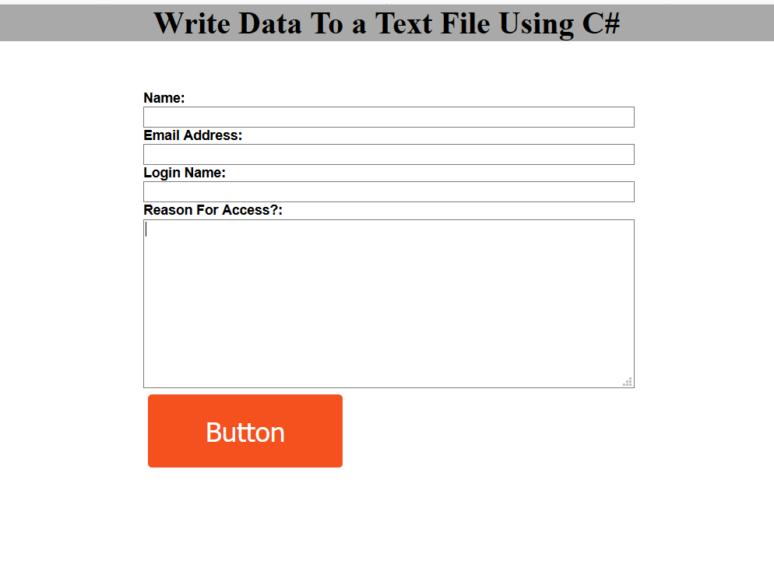

But… the heard of the application happens when the user clicks the button, which is how we will create and append the user input to the text file.

The Button_Click event triggers the server to execute a block of code. In this scenario we tell the server to (abstracted list of commands):

1. Set a file path where the file will exist.
2. Set an array of strings equal to the textbox input values.
3. Instantiate System.IO.StreamWriter object
4. Using the StreamWriter object, loop through the array and write each string to the file.
5. Write one more line to create a space between each entry.
6. Close the StreamWriter object after each use.